**Question 1 (AA1, AA2):**

a. Select 2 game engines and list 4 reasons why one particular game engine was selected (giving advantages of the game engine) and why the other was not selected.

**Unity vs Unreal Engine 4**

*For my assignment I chose Unity.*

Unity is better used for 2D Games which we are creating, vs the 3D games that unreal engine 4 is better equipped to create.

Unity allows for variety of programming languages to be used while Unreal engine 4 focuses mainly on C++.

Unity is free although is limited near a purchased version, unreal engine 4 must be purchased.

Unity is more intuitive and easier to grasp, the Unreal engine has a very easy to understand UI and use.

b. Select 2 programming languages used in game development and choose one to support the game engine chosen and list 4 of its features.

**C# vs JavaScript**

*For my assignment I chose C#.*

C# is more functional than JavaScript.

JavaScript allows for sloppy coding to be used which might end up in bad habits or non-working games.

C# can be translated into a cleaner code.

C# is easier to understand and has a better performance.

**Question 2 (SE1): Prepare detailed design documents for the game:**

a. One Game design document (State Diagram) should contain an overview of the whole game, from the Start Menu till the end showing correctly the interactions between the scenes.

Uhhhh Yes.

b. The second design document should contain a detailed State Diagram of either Level 2 or Level 3 of the game showing correctly all events and interactions happening in the scene.

Uhhhh Yes.

**Question 3 (KU 4):**

In not less than 100 words, explain why compression is needed when using media assets such as images, videos and audio. Provide examples.

Compression is a useful tool to use when you need to reduce a file original size to a minimum, as video files or image files require a higher storage than regular files, they ideally are compressed. This removes redundant information and summarizes the content that preserves as much of the original file as possible In this image / example – The data shows how compression is used in a media area, the files are being compress for a much less data.

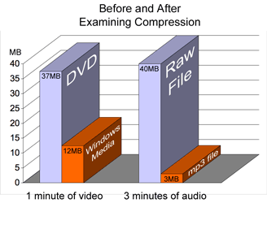

Another advantage to compressing files, is the easier possibility of transferring files to other storage or computer devices. Sharing folders can be difficult if their data is too big.